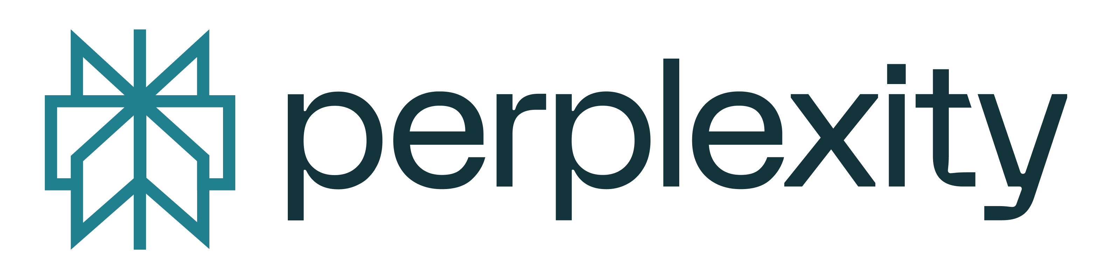
fais moi un cv en anaglais de Thierry Rouiller FKG
Voici un CV résumé en anglais de Thierry Rouiller (FKG Dentaire), prêt à l’usage.
Thierry Rouiller
Chief Executive Officer (since 2011) — FKG Dentaire SA | La Chaux‑de‑Fonds, Switzerland
Profile
Medtech executive leading a Swiss endodontics innovator across global markets. Succeeded the founder‑CEO Jean‑Claude Rouiller in 2011, scaling international distribution, advancing product innovation (file systems, endo motors, bioceramics), and strengthening quality, regulatory readiness, and clinician education.
Core competencies
- Medtech strategy & P&L leadership
- Global distribution & partnerships
- Product portfolio & innovation (endodontics)
- Regulatory/quality systems (EU/US)
- Operations & industrial scale‑up
- Clinical education & training networks
Professional experience
Chief Executive Officer — FKG Dentaire SA (2011–present)
- Leads strategy, portfolio focus (file systems, reciprocation, endo motors, bioceramics), and international go‑to‑market.
- Expanded distributor network and university partnerships; reinforced training centers (La Chaux‑de‑Fonds, Oslo, Dubai) to elevate clinical practice.
- Oversaw product generations including RaCe → RACE EVO, reciprocating systems (R‑Motion), Rooter motor platform evolution, and bioceramic ranges.
- Strengthened regulatory compliance, clean‑room capacity, and sterile product lines to meet international standards.
Earlier roles — FKG Dentaire SA
- Senior management roles supporting operations, commercial development, and innovation projects prior to CEO succession.
Selected achievements
- International Scale‑Up: Grew exports through a curated global distributor network aligned to brand and clinical strategy.
- Innovation Pipeline: Drove successive generations of shaping/cleaning systems and ergonomic motors to improve safety and efficiency.
- Education Ecosystem: Expanded hands‑on training footprint and academic collaborations to support evidence‑based adoption.
- Industrial Excellence: Enhanced manufacturing capabilities, quality systems, and sterile production lines.
Industry engagement
- Collaboration with leading universities and KOLs to validate minimally invasive endodontic philosophies (respect for canal anatomy, cleaning efficacy).
Education
- Business/engineering background (details upon request).
Languages
- French (native), English (professional).
Board & advisory
- Executive leadership at FKG; engagement with clinical partners and industry bodies.
Availability
- Speaking, partnerships, and industry collaboration in medtech and dental innovation.
Souhaitez‑vous une version “one‑page” mise en page (PDF/Word) avec puces orientées résultats et un résumé LinkedIn assorti ?
⁂

- https://fkg.ch/company/
- https://www.crownkenya.com/fkg/
- https://assets.letemps.ch/sites/default/files/media/2012/01/11/2.0.3018116890.pdf
- https://esttmco.com/en/marque/fkg-en/
- https://ch-fr.indeed.com/cmp/Fkg-Dentaire-Sa
- https://optident.co.uk/manufacturer/fkg/
- https://www.rtn.ch/rtn/Actualites/Regionale/20140829-FKG-celebre-20-ans-d-innovation.html
- https://www.pme.ch/entreprises/2019/10/16/fkg-dentaire-aux-racines-succes-savoirfaire-innovation
- https://pdf.medicalexpo.fr/pdf/fkg-dentaire/race-family/72216-156766.html

